**DSC 424: Advanced Data Analysis and Regression**

**Assignment 02**

**Name: Sidhant Thakur**

**Student ID: 2020181**

**Problem 1**

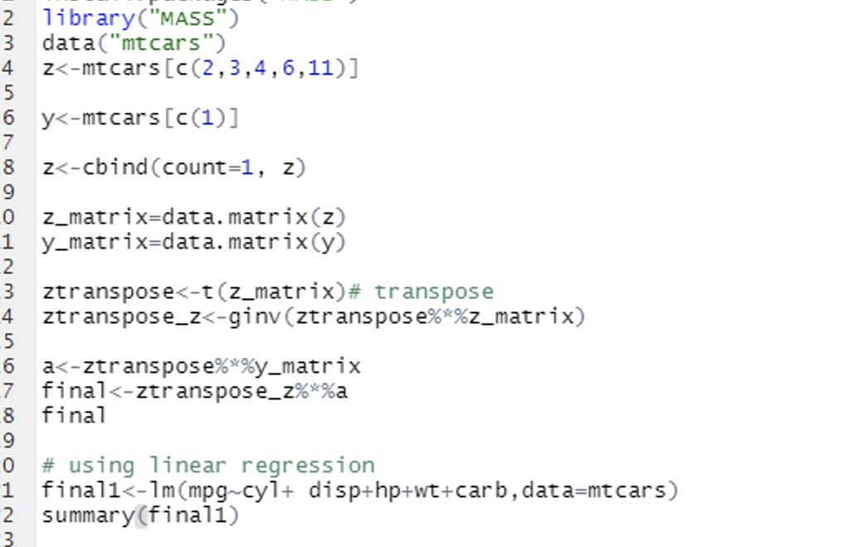

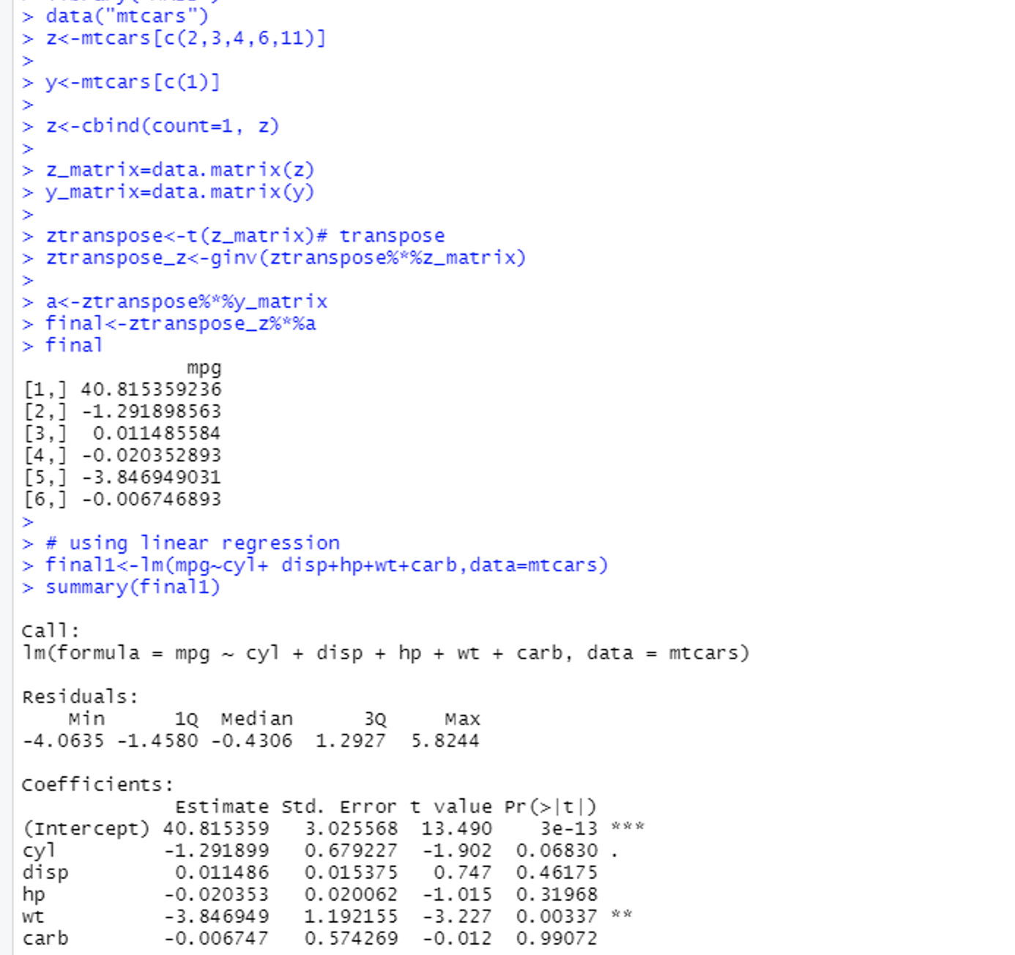

Manual calculation and r have the same output.

**Problem 2**

**a)**

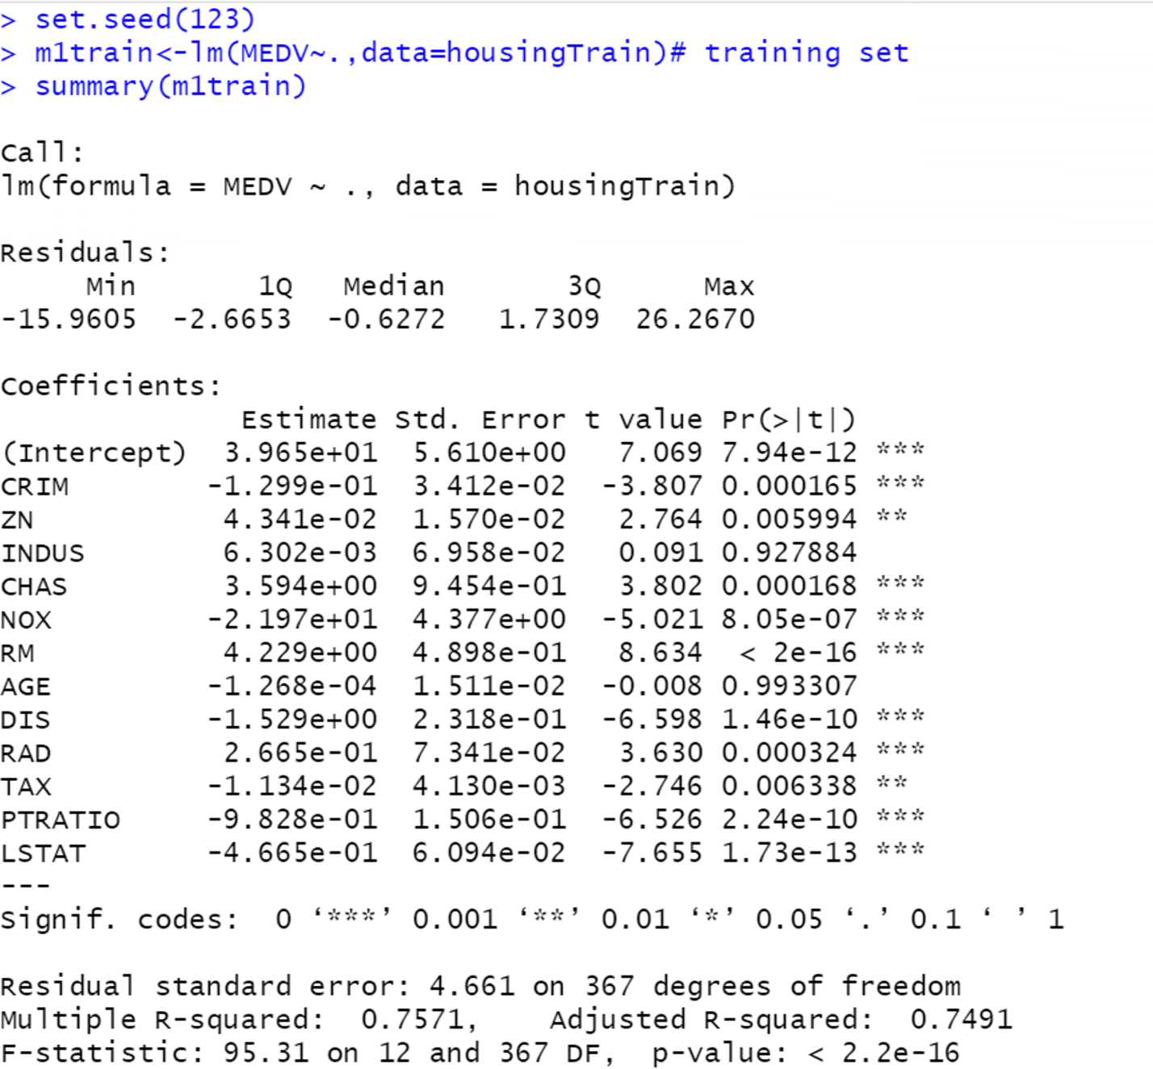

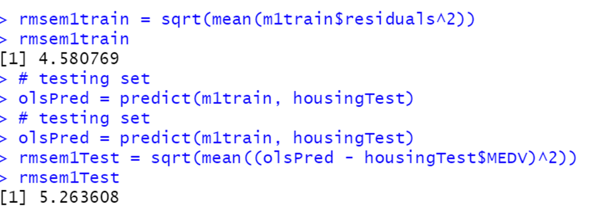

The adjusted R-squared of the training set is 0.7491(74.91%), which mean that 74.91% of the variability in y is explained by our regression model. So, according to me our model is performing quite well, because closer the 1 r-square is the better it is.

There is a small difference between the testing and training sets, so there is no indication of overfitting.

**b)**

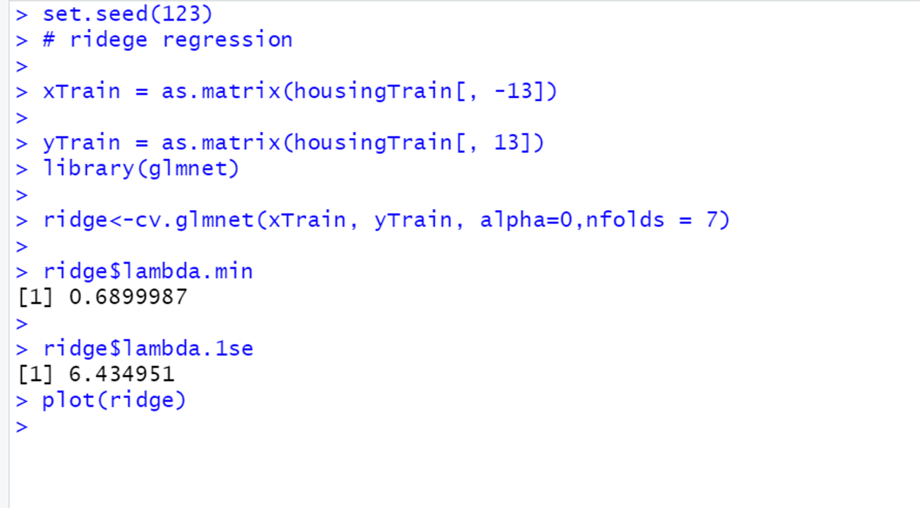

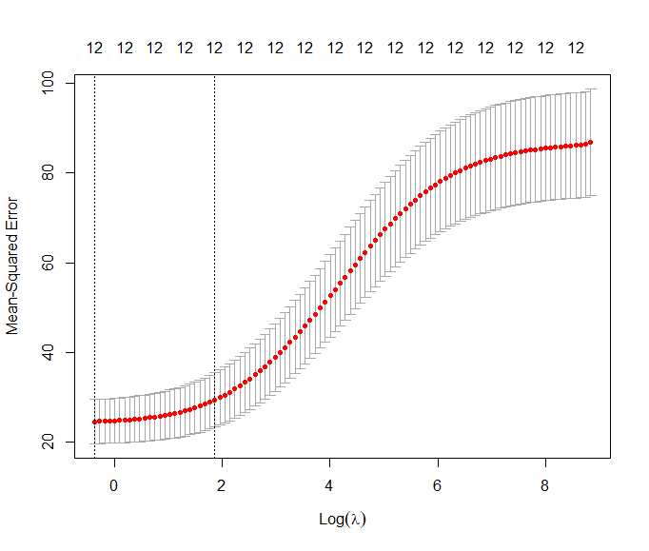

The plot shows the lambda vs mean square error for ridge regression.

It has a lambda.min value of 0.68 and lambda.1se value of 6.43, which minimize mean square error and minimize prediction window.

From the graph we can see that, between lambda.min and lambda.1se, the mean square error seems to be gradually increasing with respect to the log(lambda)but after the lambda.1se, the value of mean square error increases at very fast rate

And at the top we can see that the number of variables remain the same.

**c)**

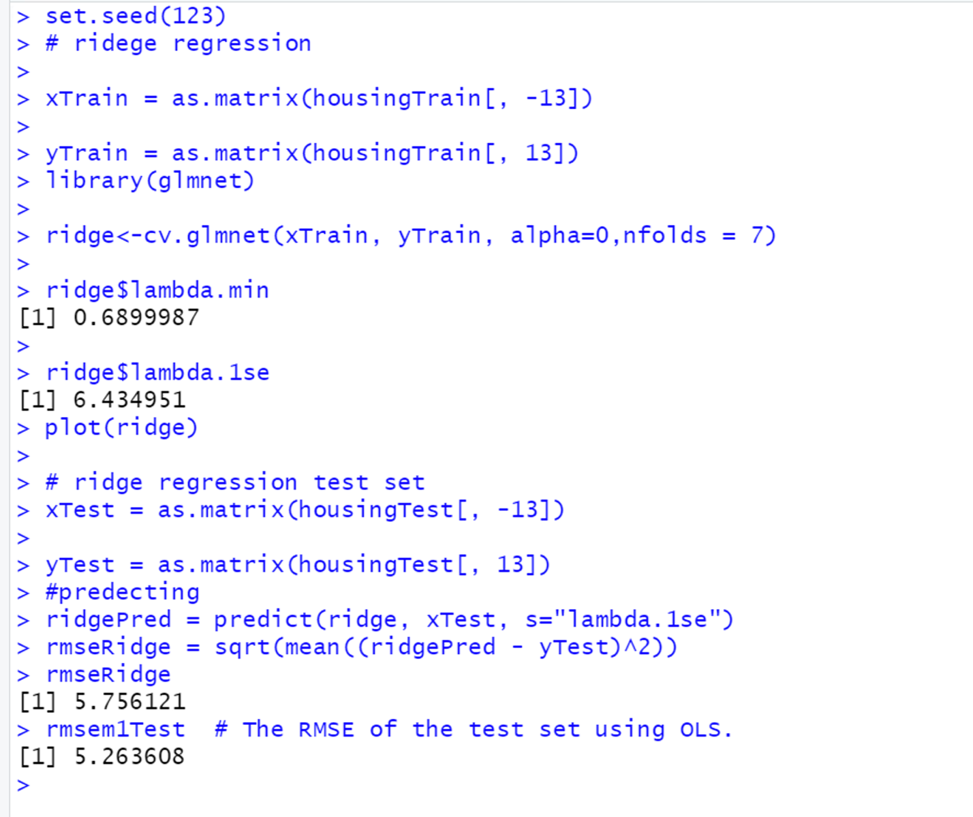

The RMSE for the ridge regression is 5.756

The RMSE for the OLS is 5.26.

So, here OLS appears to be doing better on the test set than Ridge regression.

**d)**

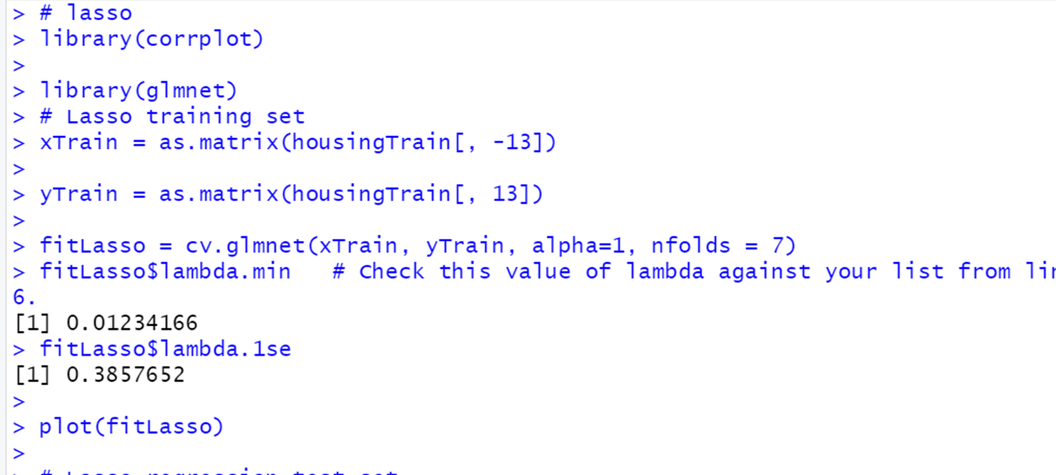

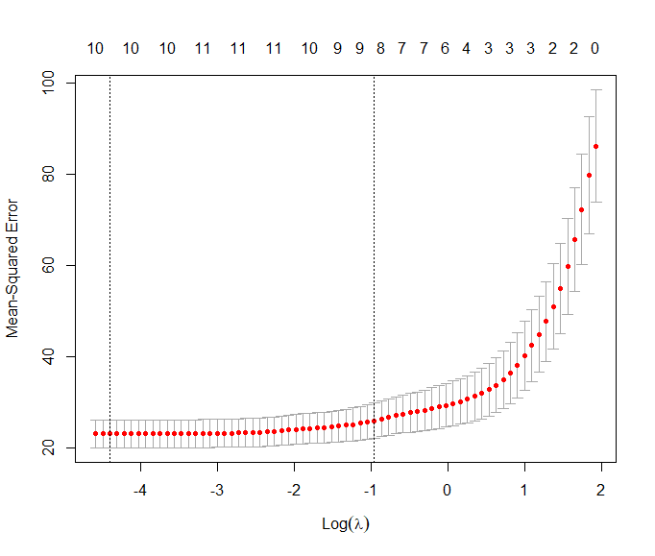

The plot shows the lambda vs mean square error for LASSO regression.

It has a lambda.min value of 0.012 and lambda.1se value of 0.38, which minimize mean square error and minimize prediction window.

From the graph we can see that, between lambda.min and lambda.1se, the mean square error seems to be static with respect to the log(lambda)but after the lambda.1se, the value of mean square error increases exponentially.

And at the top we can see that the number of variables start to decrease as, the value of the mean-square error increases with respect to log(lambda)

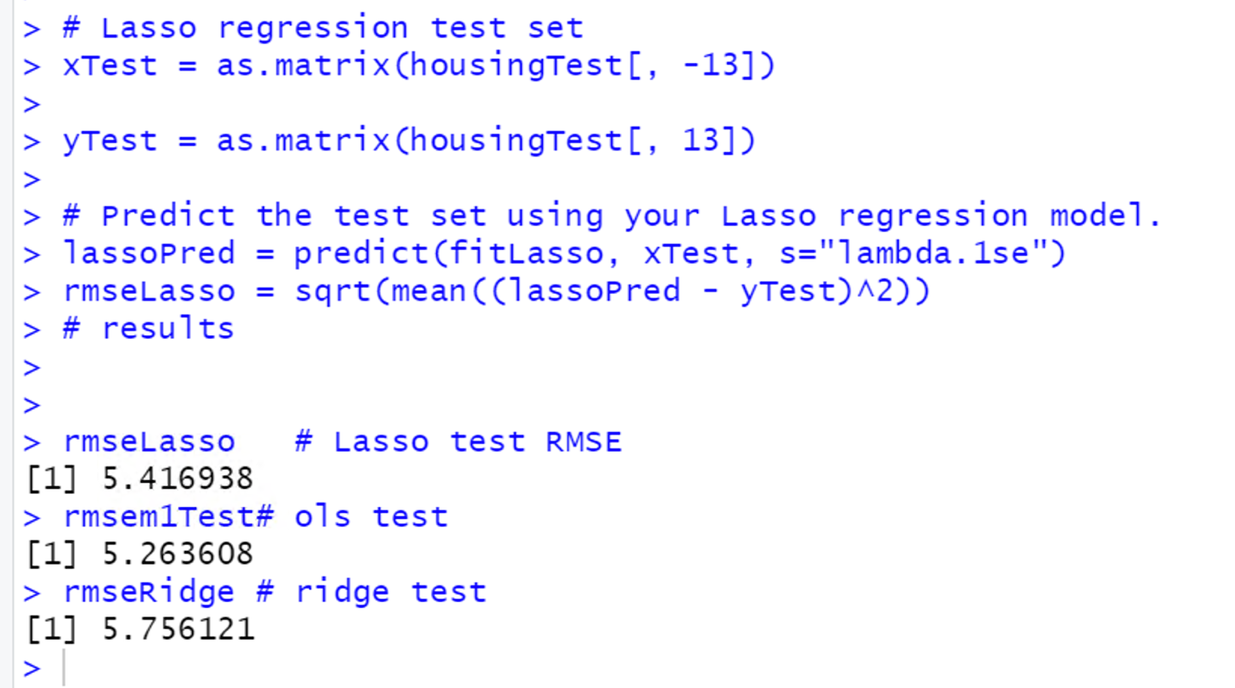

The RMSE for the Lasso regression is 5.41

The RMSE for the ridge regression is 5.756

The RMSE for the OLS is 5.26.

So, in this case, OLS appears to perform better, followed by Lasso regression, and finally by Ridge regression.

**e)**

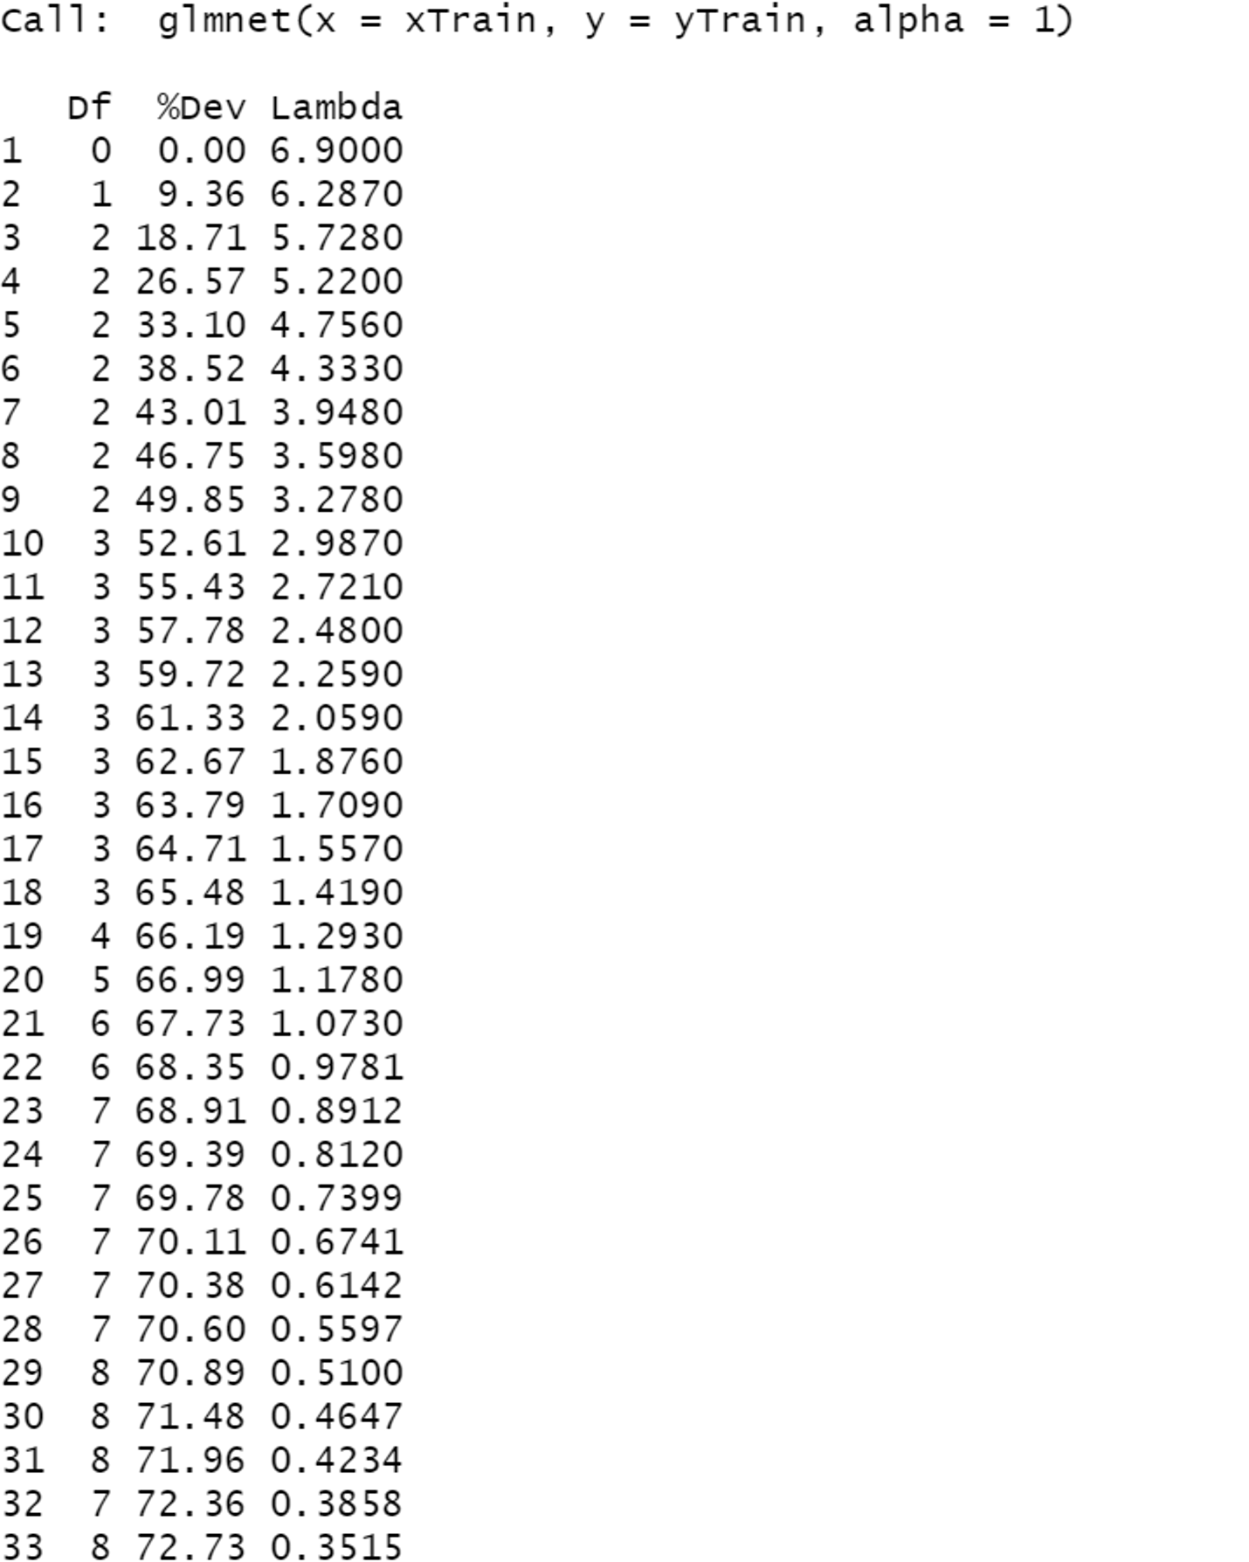

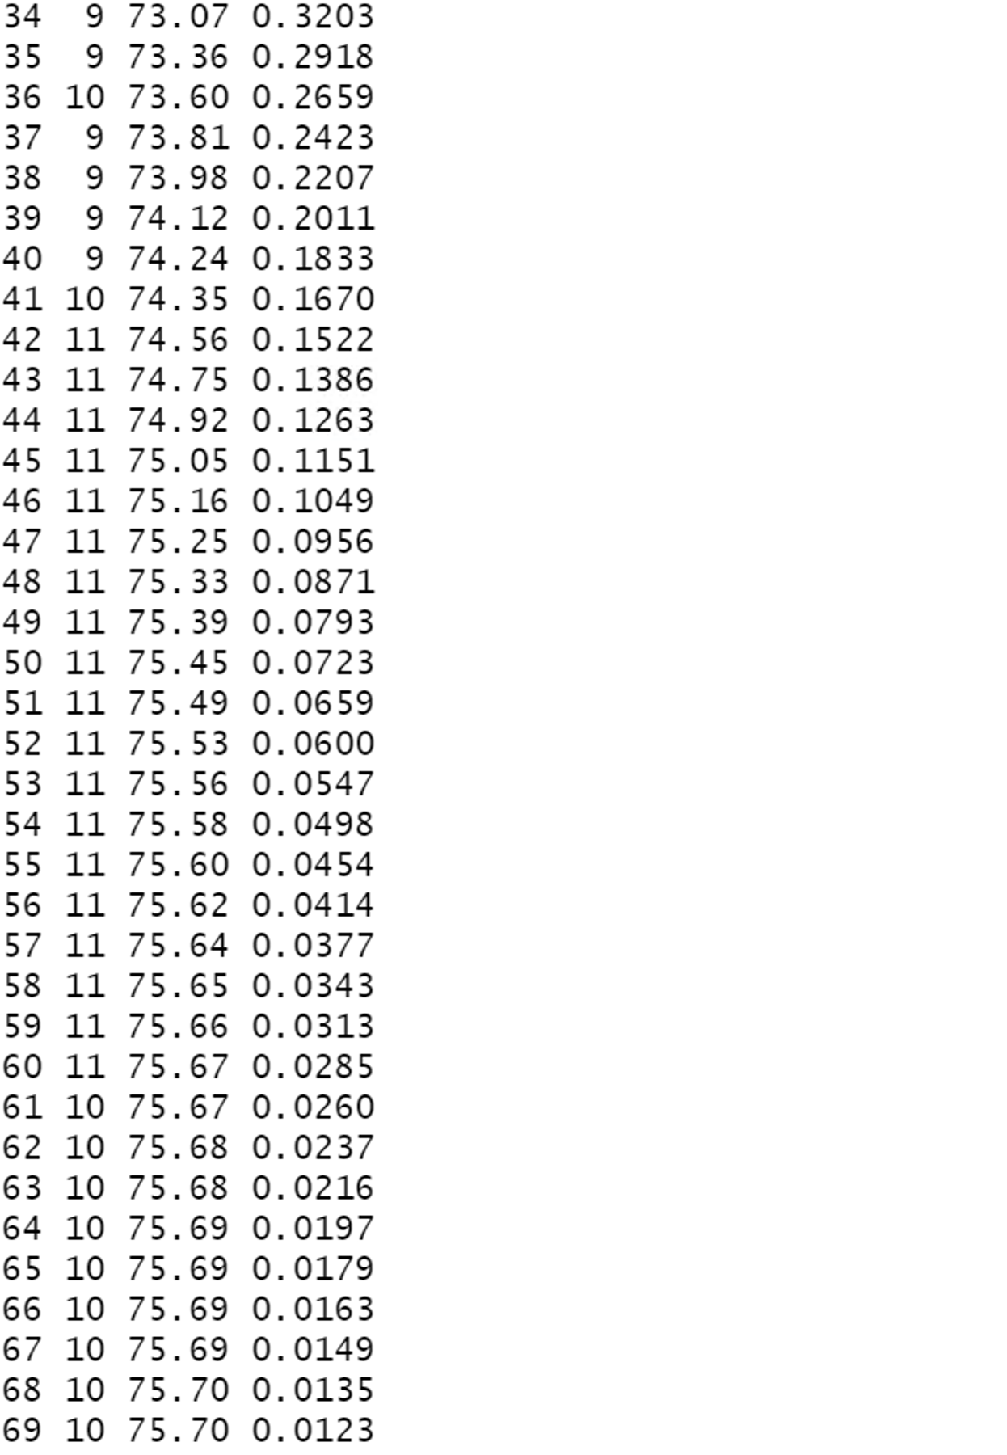

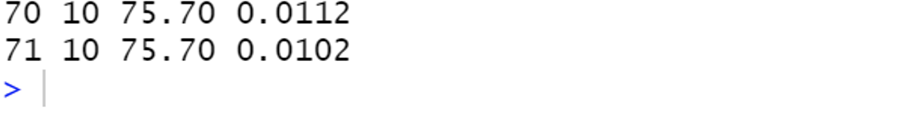

As, the lambda value start decreasing as, the DF start increasing. But at 32, when lambda value is 0.38 the DF decrease to 7.

After that, the lambda value again starts decreasing, but at 37, when lambda value is 0.24, the DF becomes 9

**Lambda.1se**



7 variables are selected at lambda.1se

72.36% of the variance is captured at lambda.1se

**g)** From, above three model, I will go with the LASSO regression, because it will do feature selection for me. Although, the RMSE for the Lasso regression is 5.41, which is greater than OLS regression but less than ridge regression.

**Problem 3**

**a)**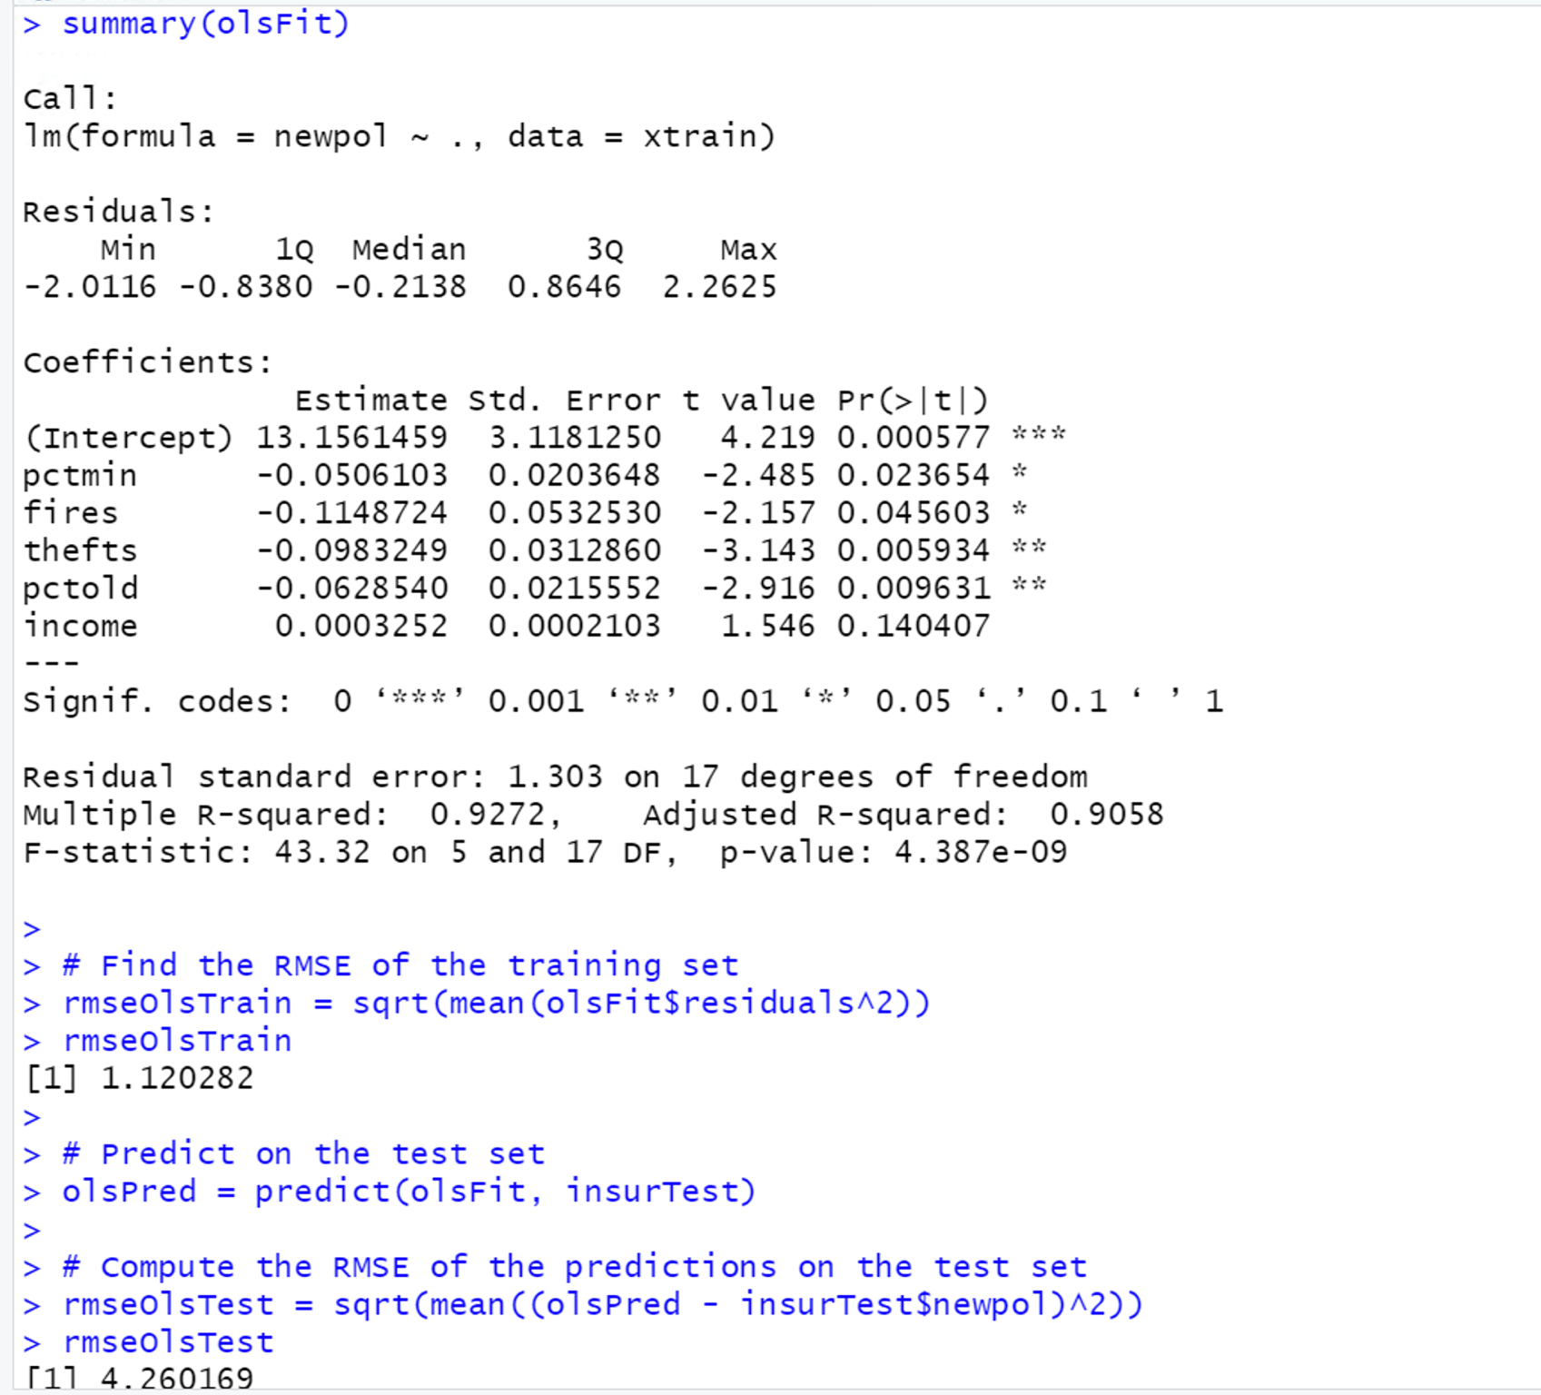

The adjusted R-squared of the training set is 0.9058(90.58%), which mean that 90.58% of the variability in y is explained by our regression model. So, according to me our model is performing quite well, because closer the 1 r-square is the better it is.

There is a large difference between the testing and training sets, so there is a indication of overfitting in our model

**b) Alpha =0**

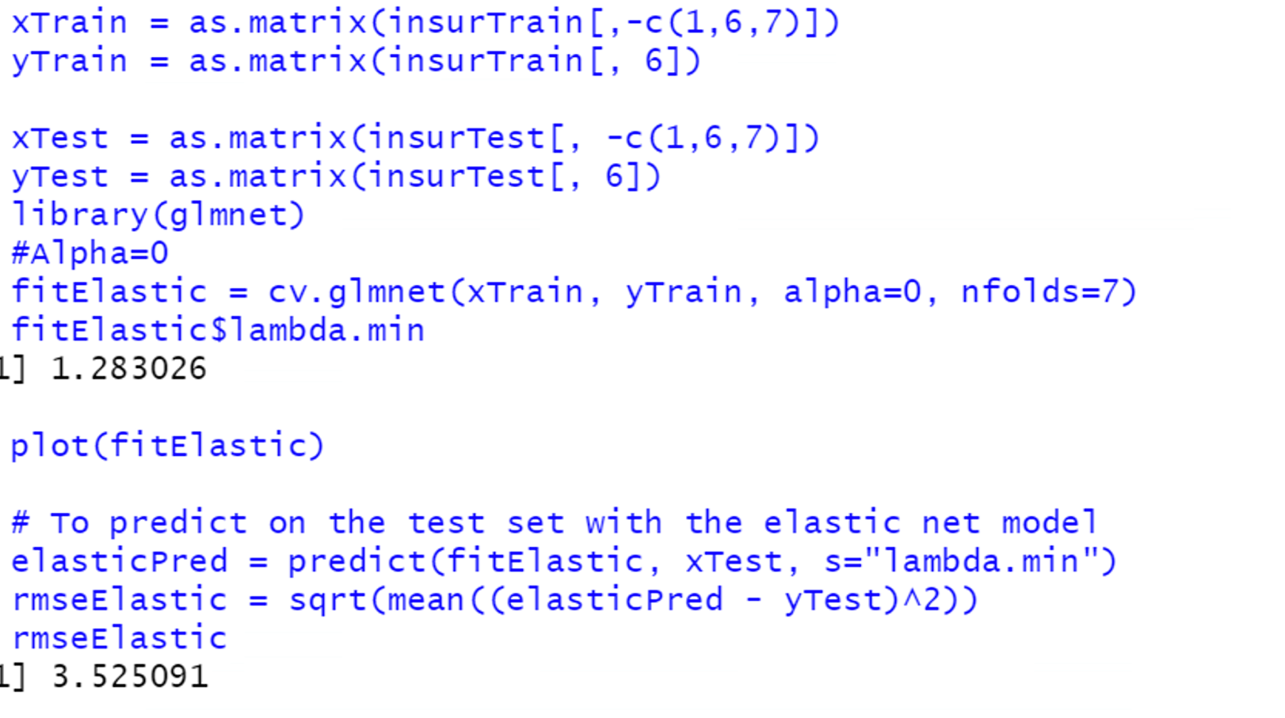

**Alpha= 0.25**

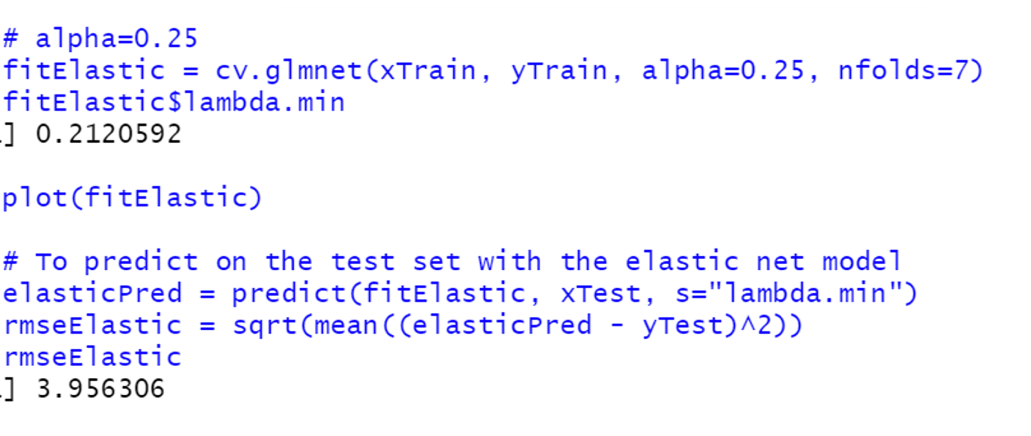

**Alpha=0.5**

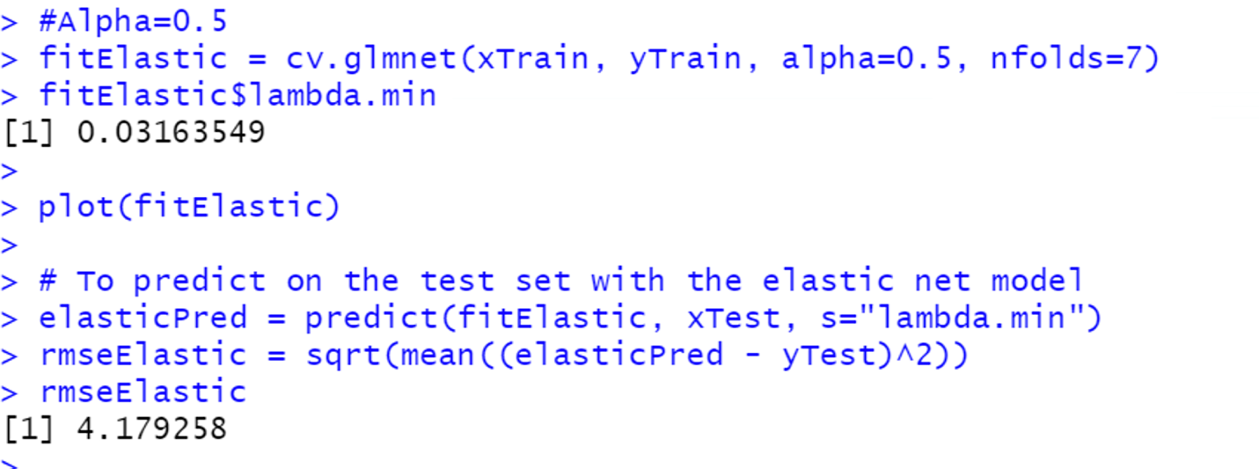

**Alpha=0.75**

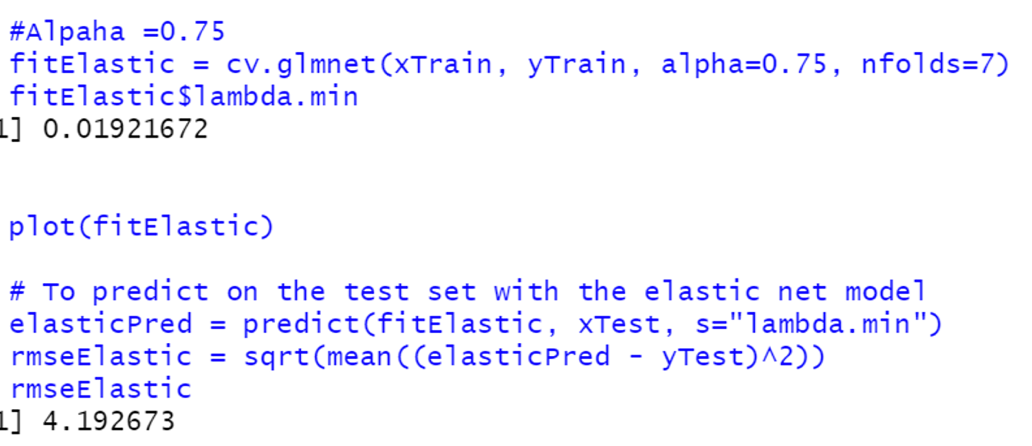

**Alpha=1**

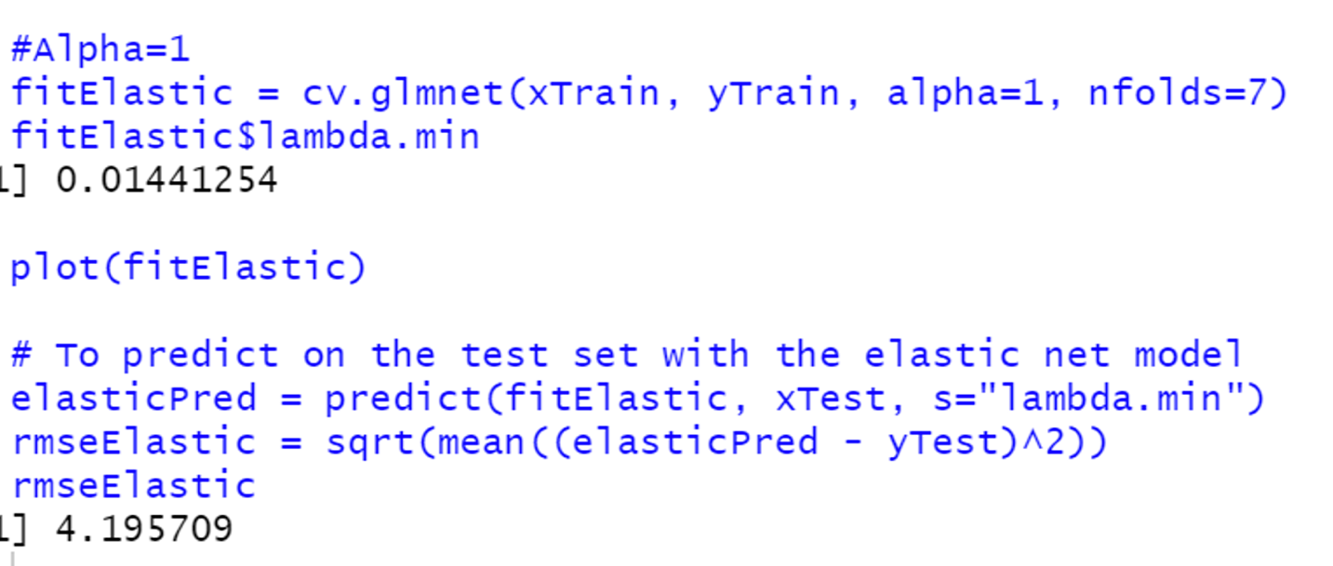

**c)** First, I have run elastic net, then I have determine the coefficient of the model and after that I have run lm() function to get r-square of the model

**R-square for Alpha =0**

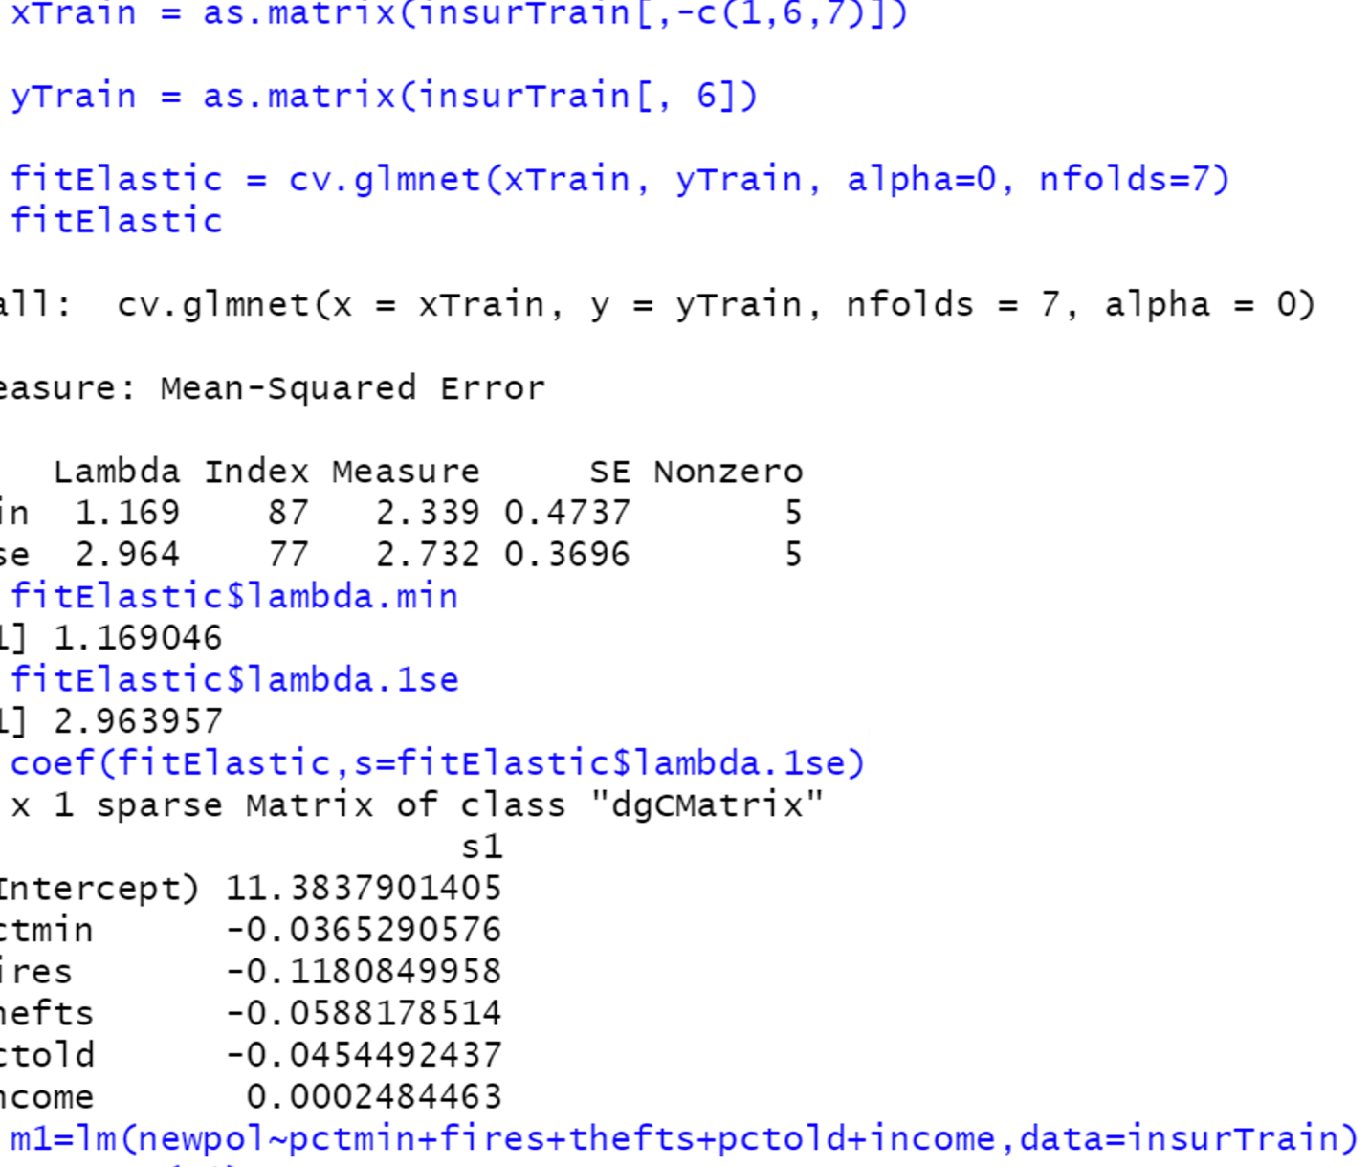

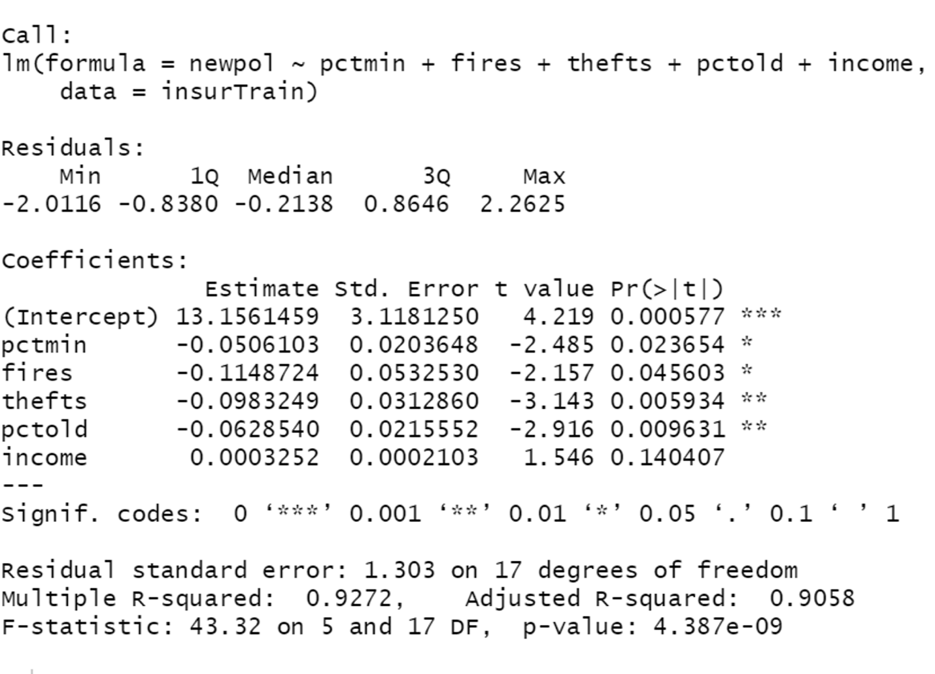

The adjusted R-square is 0.9058(90.58%), which mean that 90.58% of the variability in y is explained by our regression model.

**R-square for Alpha= 0.25**

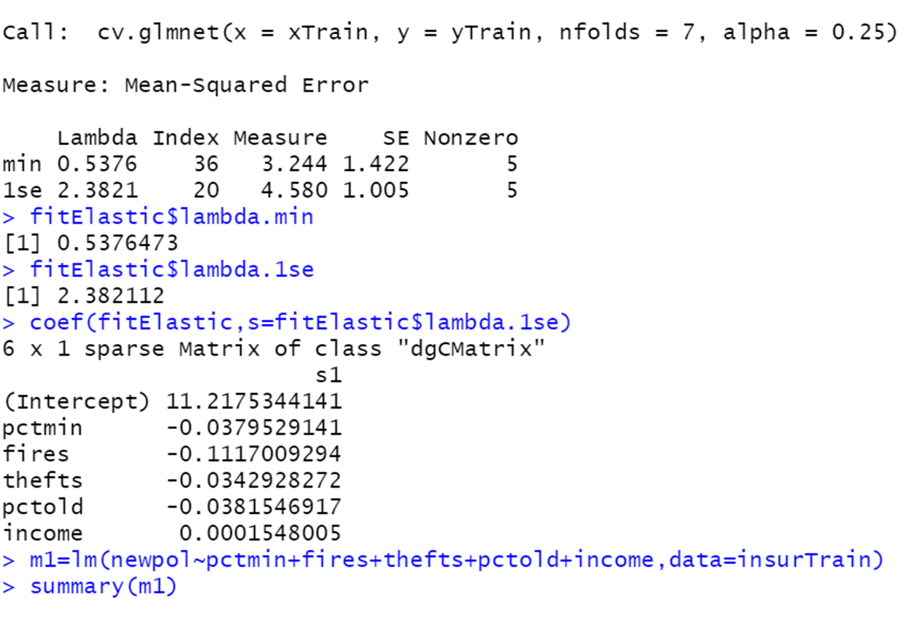

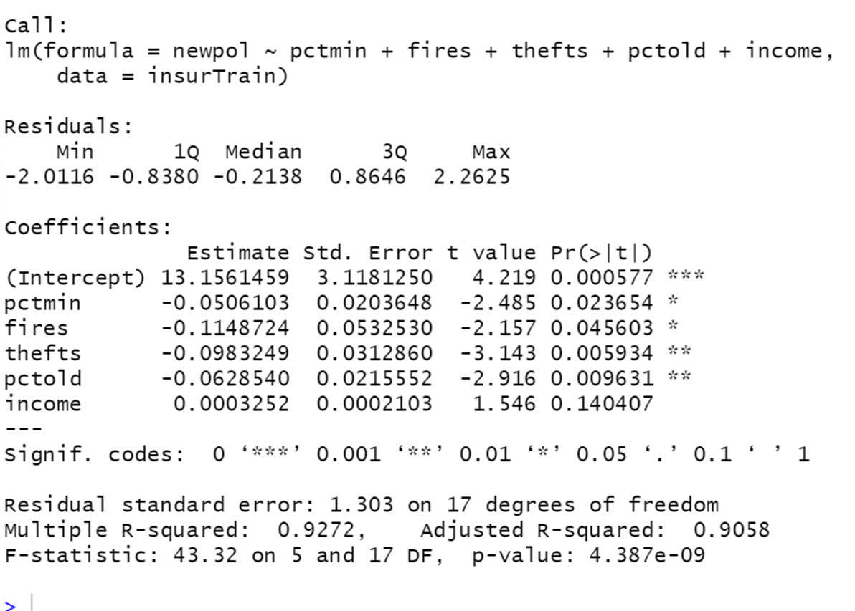

The adjusted R-square is 0.9058(90.58%), which mean that 90.58% of the variability in y is explained by our regression model.

**R-square for Alpha= 0.5**

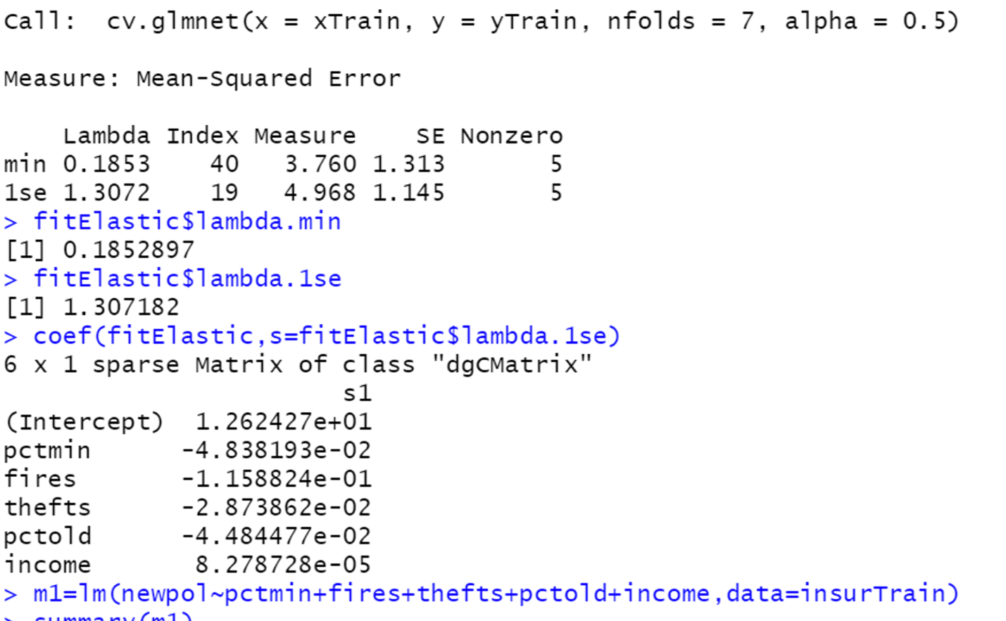

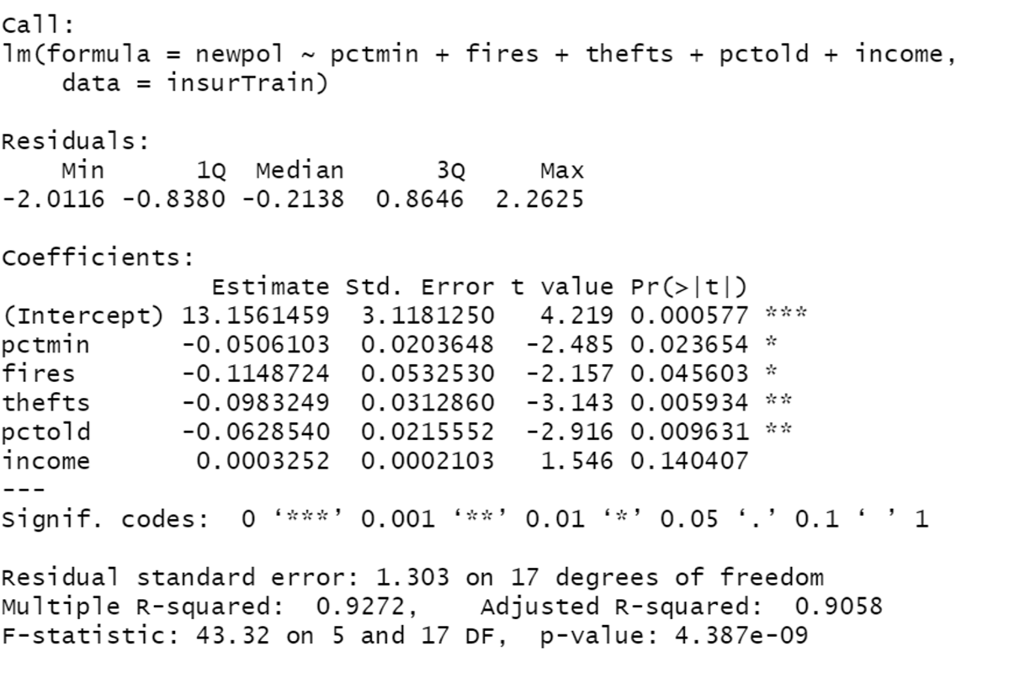

The adjusted R-square is 0.9058(90.58%), which mean that 90.58% of the variability in y is explained by our regression model.

**R-square for Alpha= 0.75**

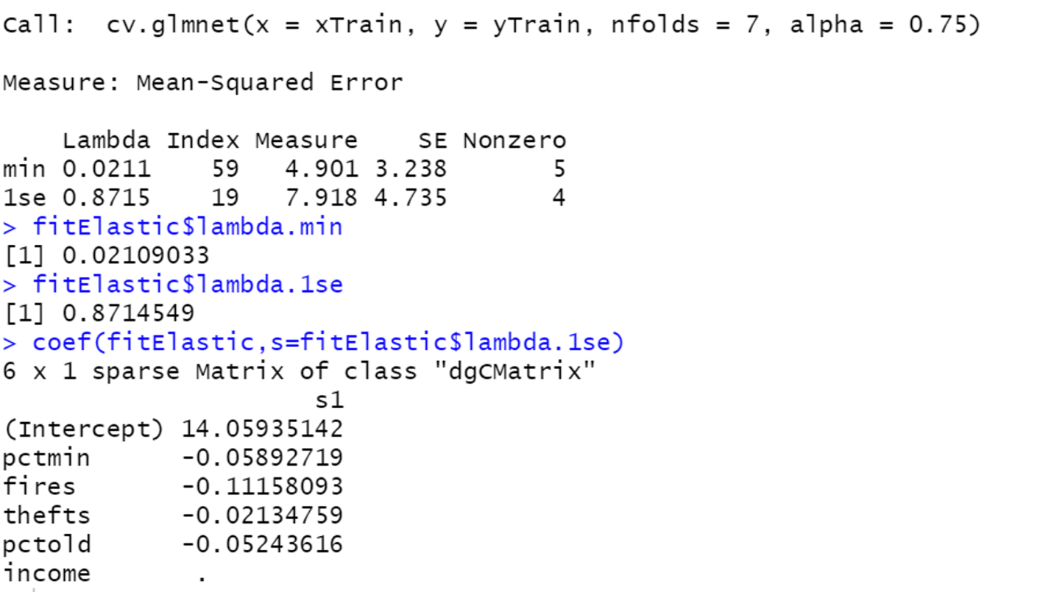

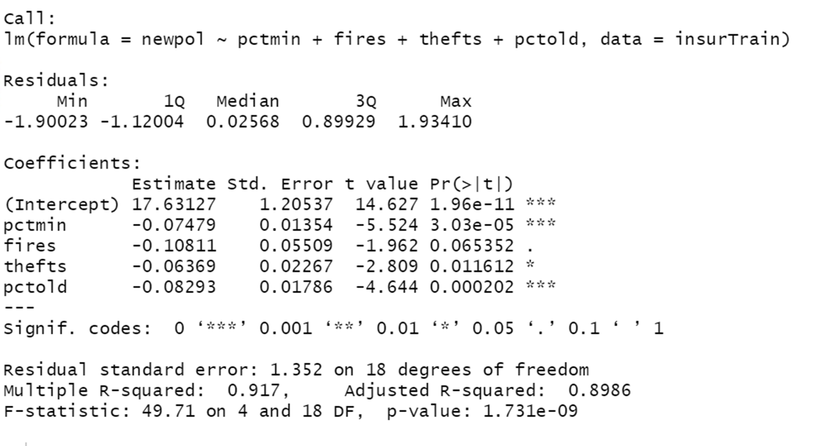

The adjusted R-square is 0.8986(89.86%), which mean that 89.86% of the variability in y is explained by our regression model.

Here alpha 0.75 remove the income from the model

**R-square for Alpha=1**

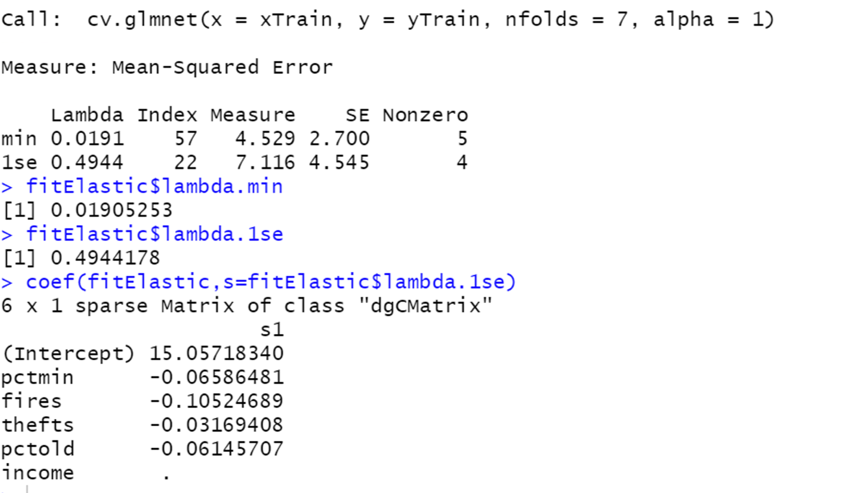

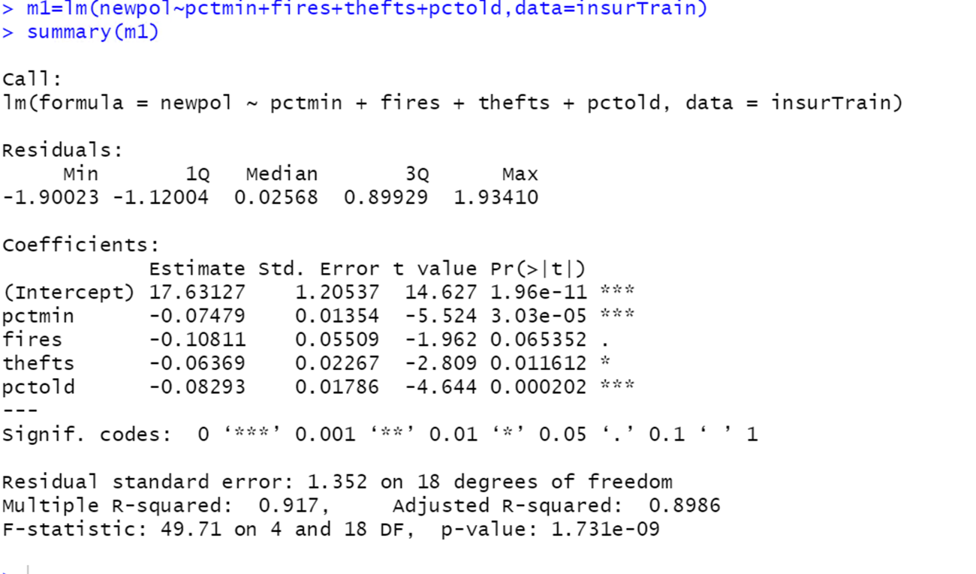

The adjusted R-square is 0.8986(89.86%), which mean that 89.86% of the variability in y is explained by our regression model.

Here, alpha 1 remove the income from the model

**RMSE for alpha =0**

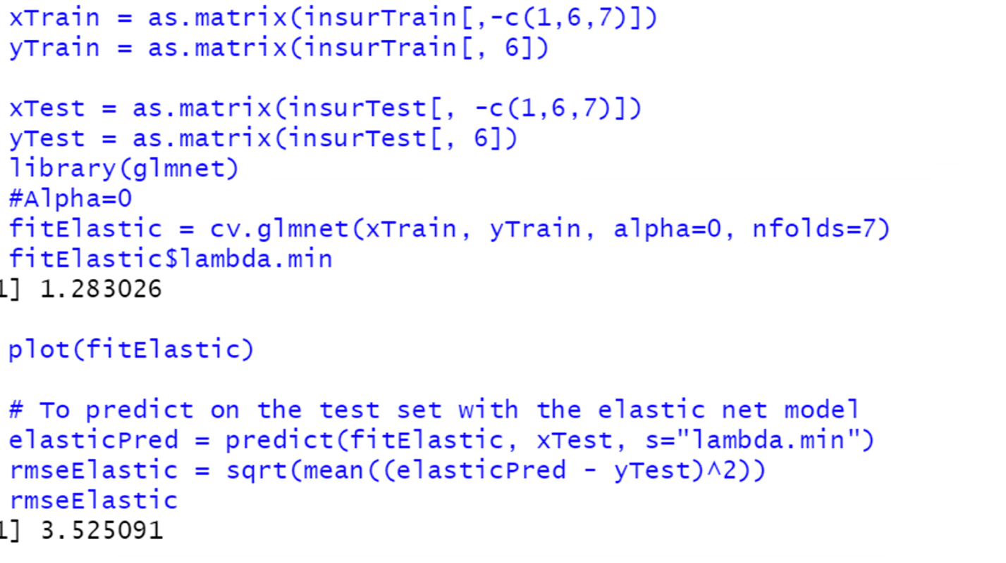

**RMSE for alpha =0.25**



**RMSE for alpha =0.5**



**RMSE for alpha =0.75**



**RMSE for alpha =1**



**d)** According to me, the alpha =0 model is performing the best because in this model we have a smallest RMSE value of 3.52 as compared to all other model’s alpha values. Moreover, the adjusted R-square is 0.9058(90.58%), which mean that 90.58% of the variability in y is explained by our regression model.

As our alpha value is 0, so our chosen model influenced more by the ridge regression. Moreover, ridge regression also helps to reduce the multicollinearity in the model.

**Problem 4**

**a)** The dataset is 395 rows long and contains 30 independent variables. But in the model matrix, on the other hand, has n = 395 rows and p = 39 columns. Because there are four categorical predictors with multiple levels, which automatically converts it into dummy coded variables. So, at last dataset size is 395 and contain 39 independent variables

**b)** Yes, there is the evidence of overfitting in the database, we can check it by MSPE values.

**c)** They evaluate the performance of each regularized regression technique by using the average MSPE values. Here they did 100 random split of data and record the smallest MSPE, which reveals that the lasso with lambda performed the best most frequently (22% of the time), followed by the elastic net with lambda (14% of the time), the ridge (13% of the time), and stepwise regression with AIC (11% of the time) or BIC (10% of the time).

The lasso and elastic net with lambda were rarely the best method (8% and 7%, respectively), and the p-value selection methods with p < 0.05 and p < 0.15 showed a similarly poor performance (5% and 9%, respectively), Finally, note that the OLS solution was best only 1% of the time. T

**d)** The issue that I identify is that they are using k -fold cross validation for ridge and lasso model fitting, but for OLS they are not using it.